RAVONNE THOMAS-MATTHEWS

Reducing Road Casualty in the UK

# Project Overview:

The United Kingdom’s Department for Transport (The Client) wishes to reduce the number of Road Causalities caused by motor-vehicles. In order to reduce the number of causalities, the client has concluded that an analysis of the factors that cause causalities is needed. The purpose of this project is to do just that, provide an analysis of the major factors leading to road casualties, and subsequently use any trends and patterns to provide preliminary solutions to the problem

# Business Tasks:

* Determine what metrics have the greatest correlation or causation on road casualties
* How can we reduce the number of road casualties?

# Data

The datasets used are publicly available <data.gov.uk>, and are published by the Department for Transport and licensed under the [Open Government Licence.](https://www.nationalarchives.gov.uk/doc/open-government-licence/version/3/)

The three datasets used are [Road Safety Data - Casualties 2020](https://data.dft.gov.uk/road-accidents-safety-data/dft-road-casualty-statistics-casualty-2020.csv), [Road Safety Data- Vehicles 2020](https://data.dft.gov.uk/road-accidents-safety-data/dft-road-casualty-statistics-vehicle-2020.csv), and [Road Safety Data-Accidents 2020](https://data.dft.gov.uk/road-accidents-safety-data/dft-road-casualty-statistics-accident-2020.csv).

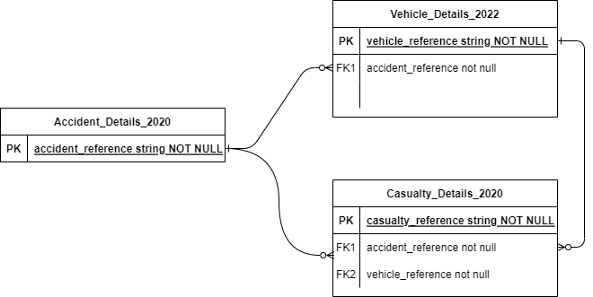The datasets are linked by foreign keys ‘casualty_reference’, ‘vehicle_reference’ and ‘accident_reference; depicted by diagram below